….and be thankful :-)

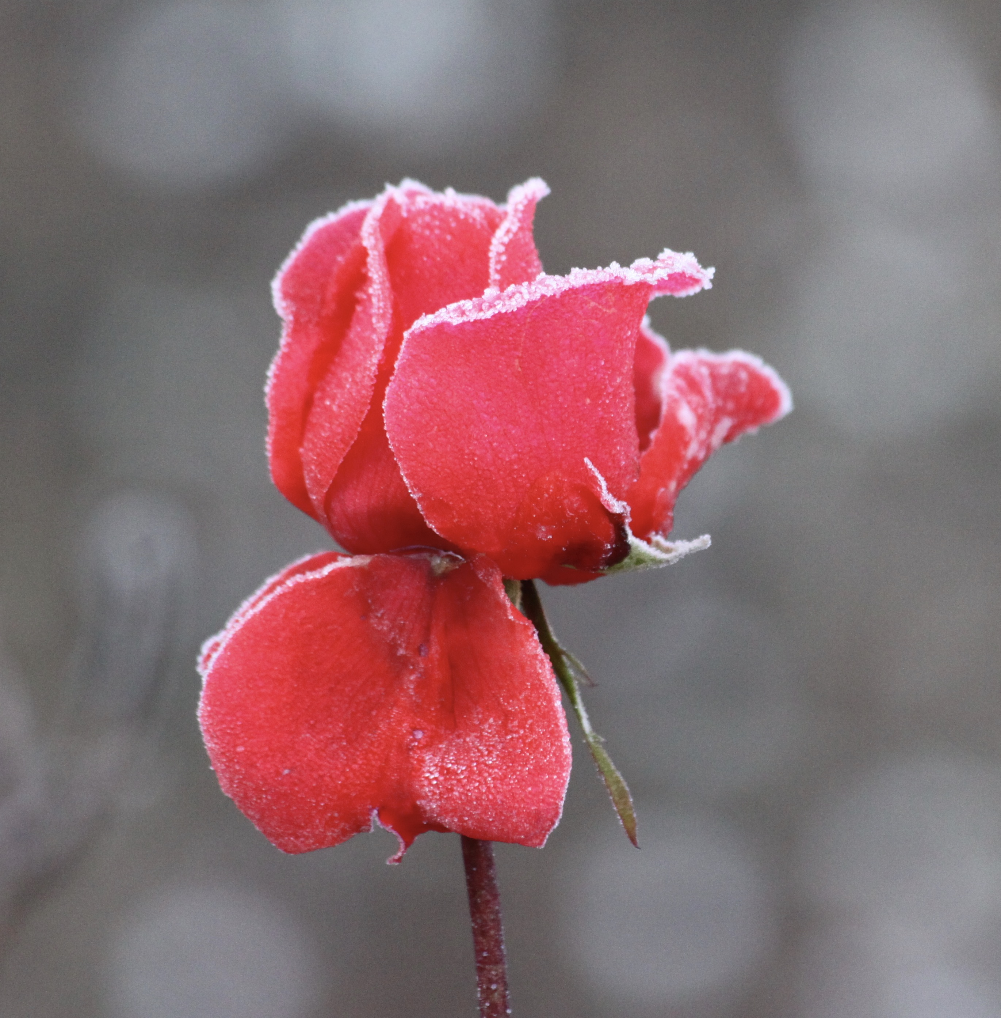
Out in creation is a great place to be, but it’s easy to stay inside when it gets cold and wet and miss how special outside can be in the darker half of the year.
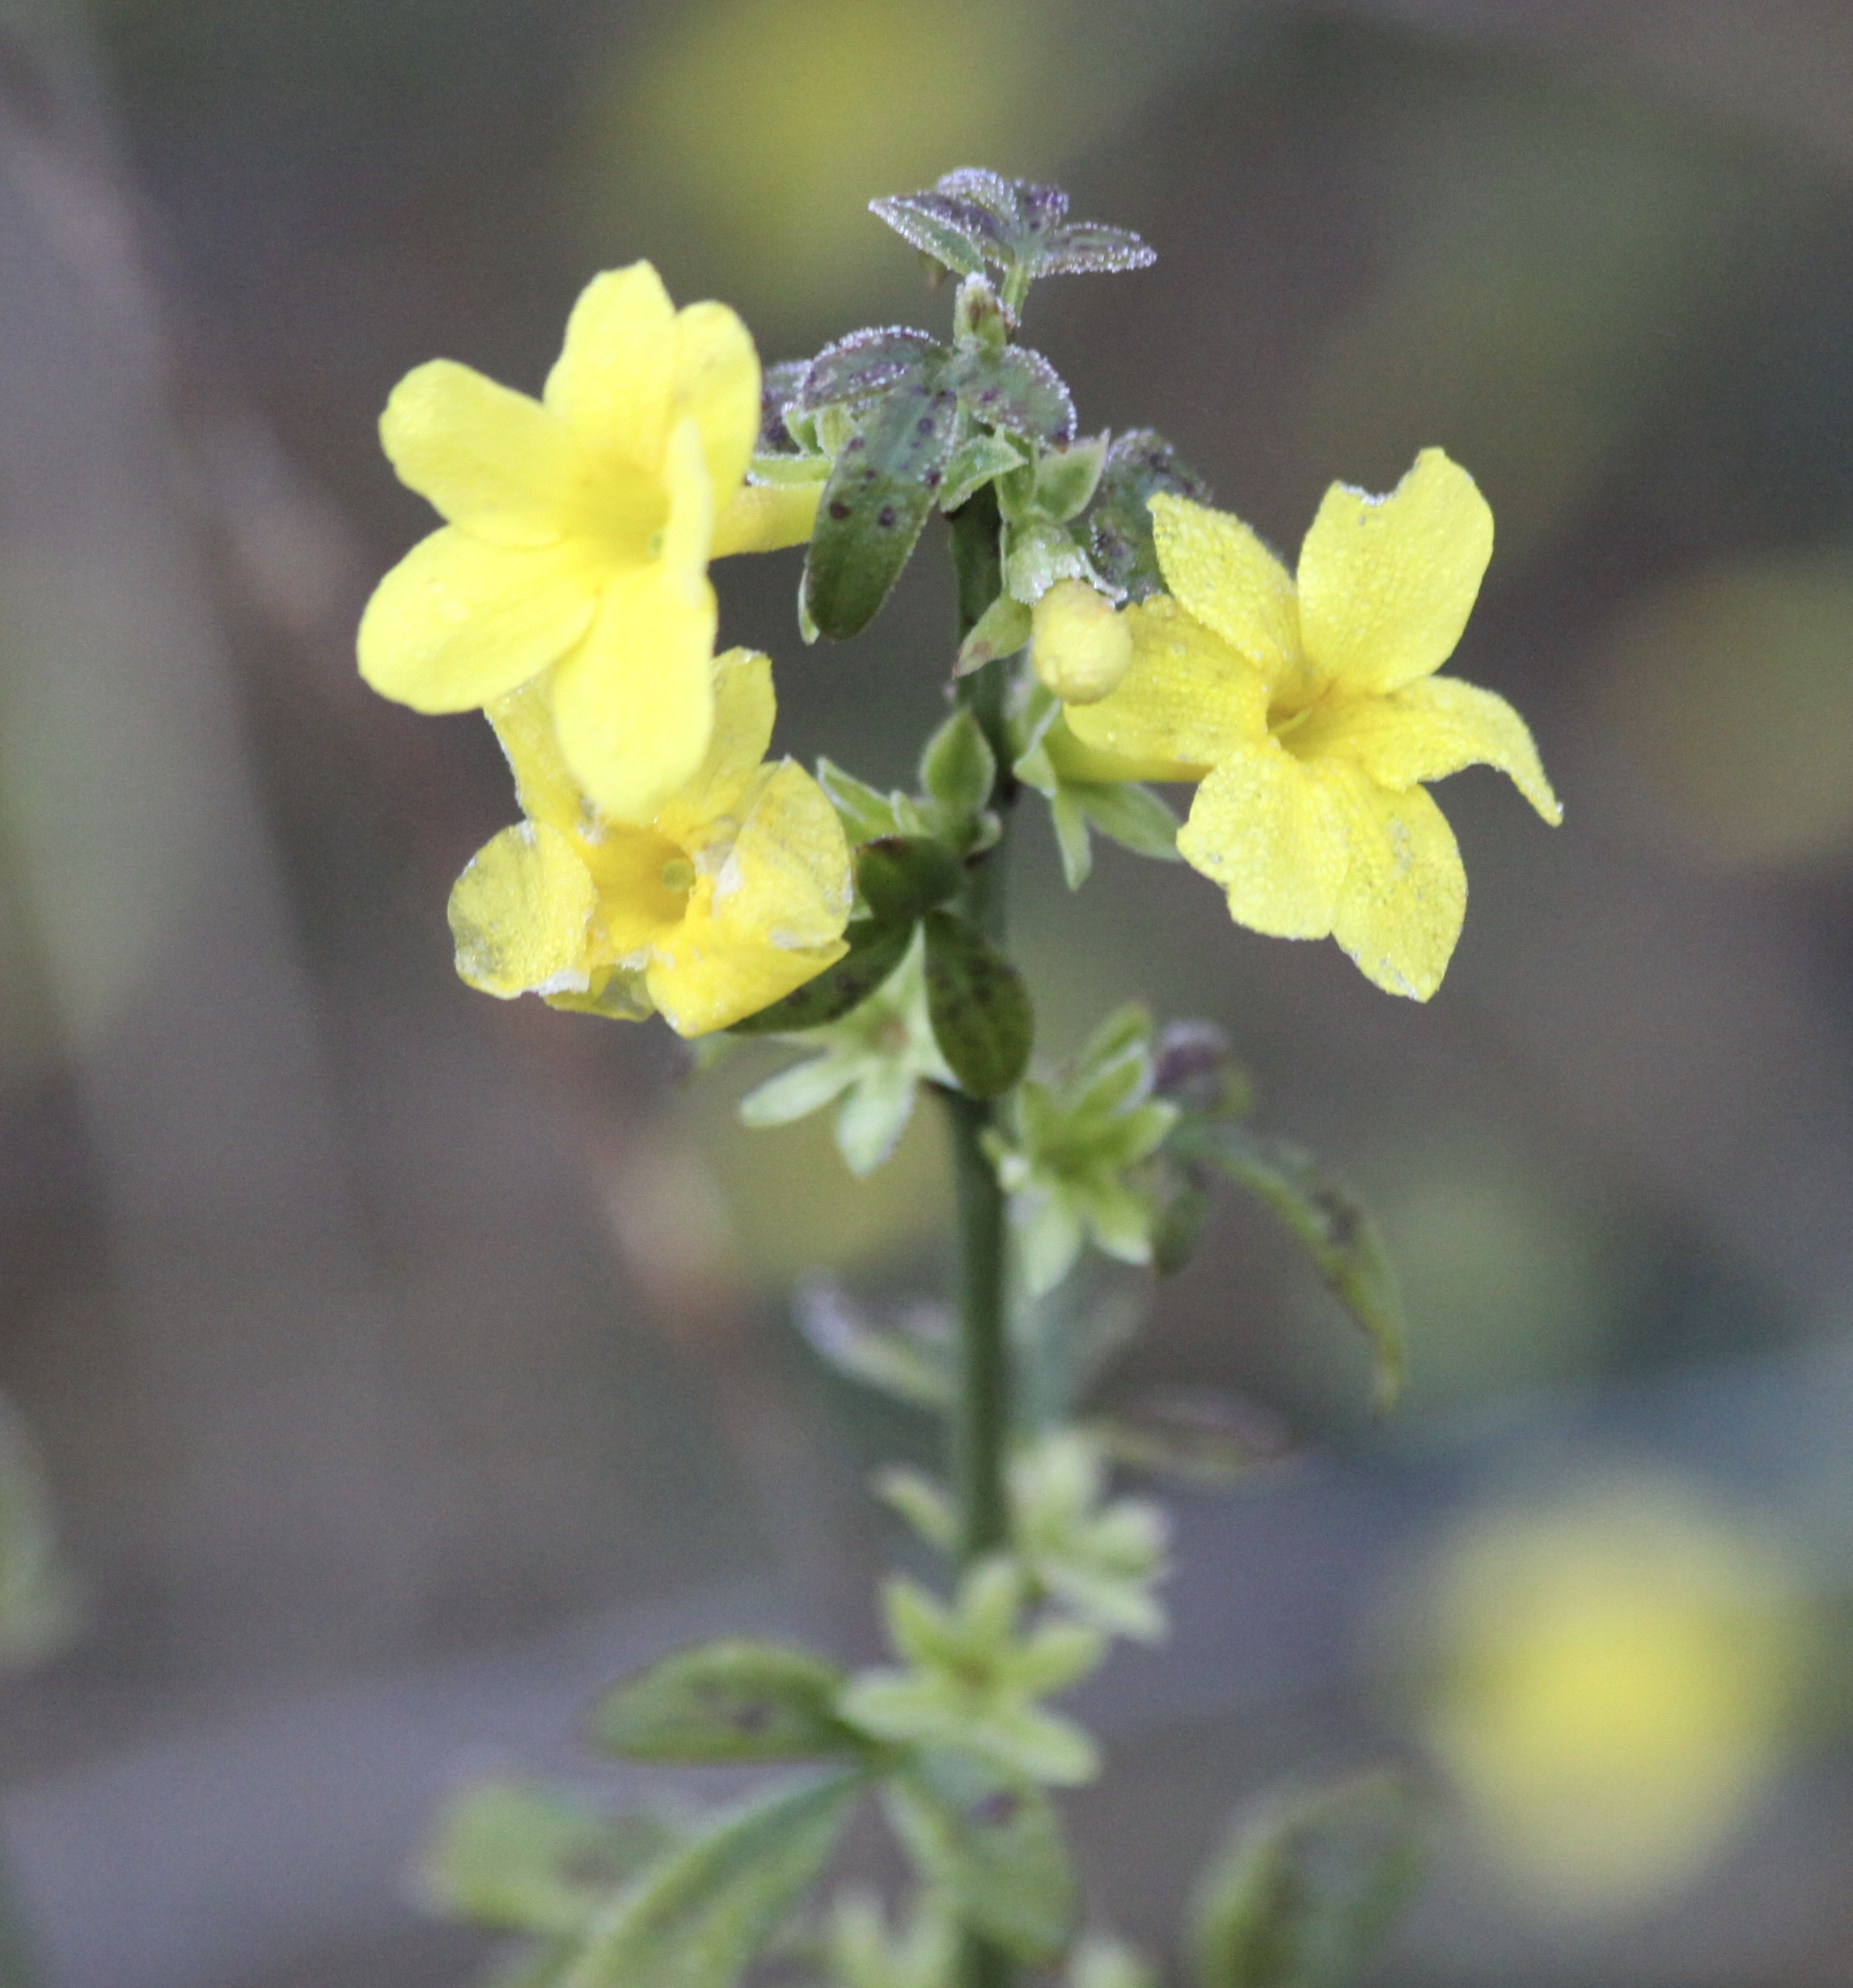
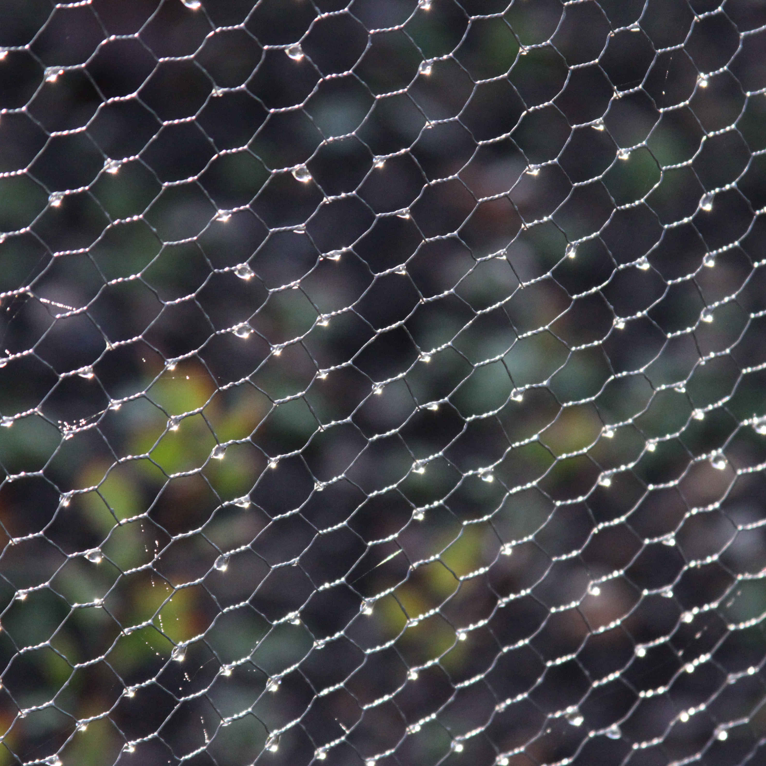
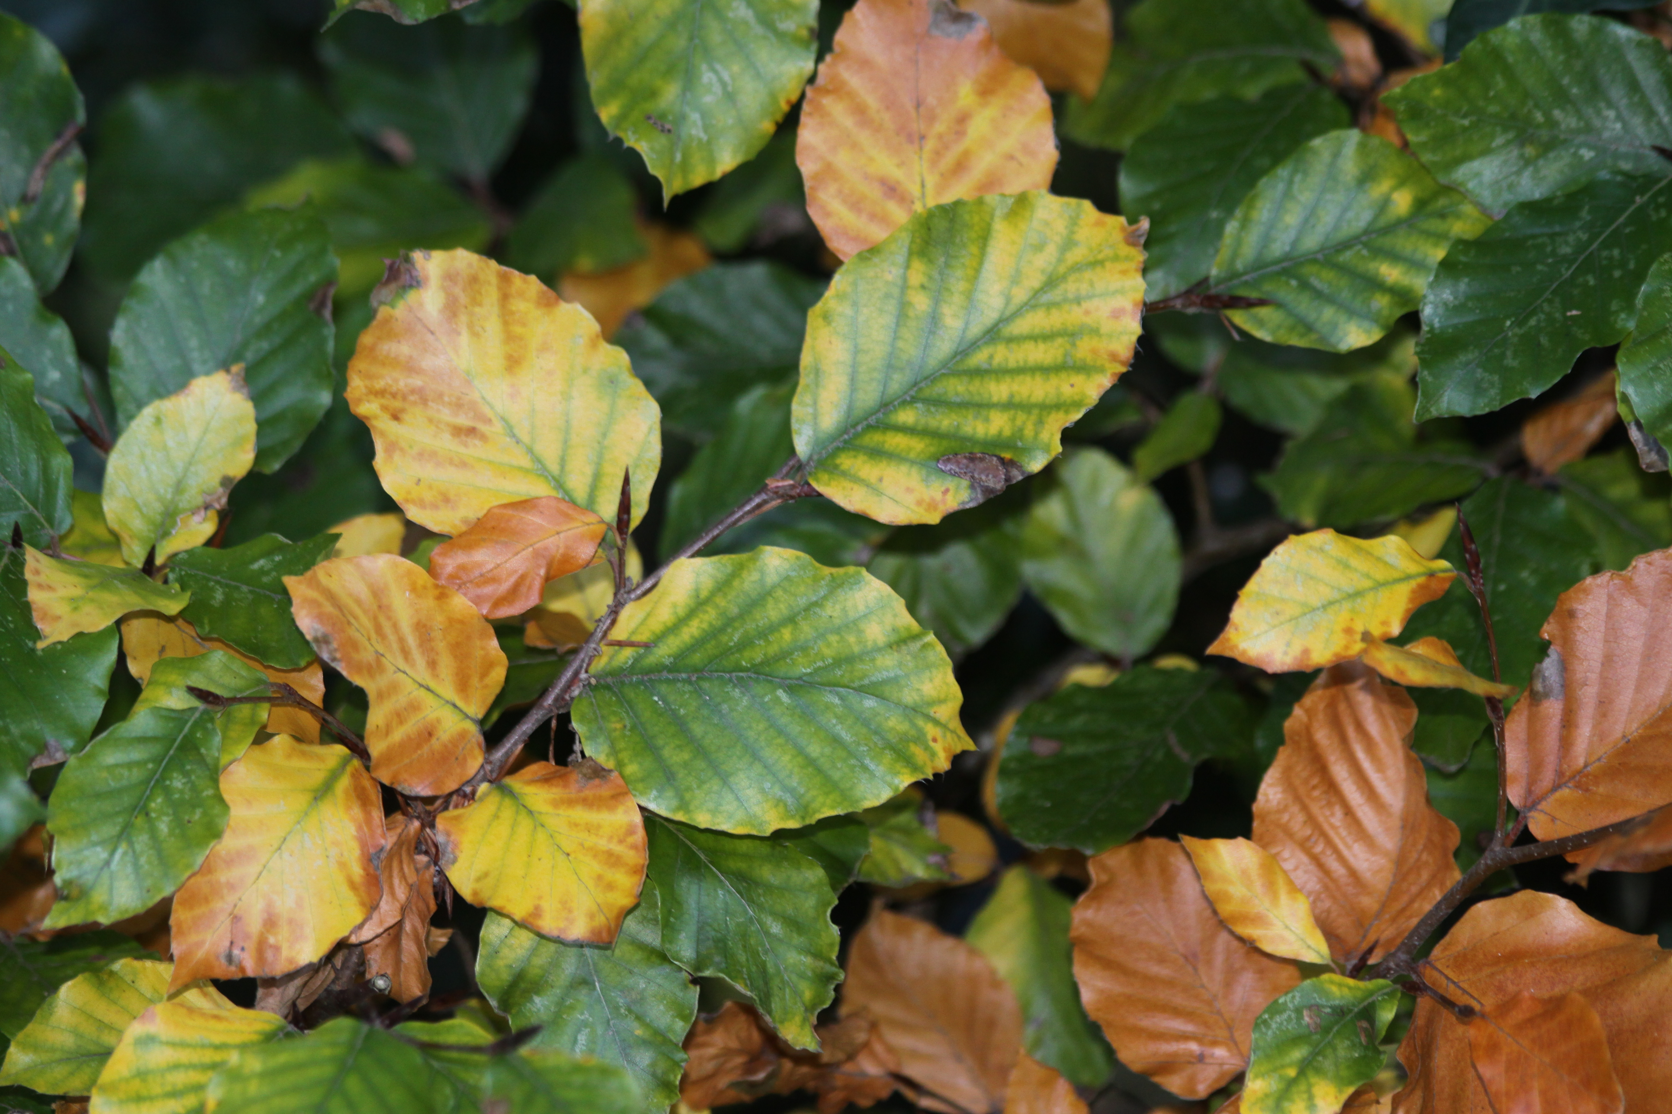
Below are 24 outside activities - nothing complicated - just ideas for things to do that use all of your senses whether you are out for a walk or in your garden (if you have one.) Choose one thing to do each day during Advent (the season that runs from Dec 1st to Christmas Day), connect with creation, and give thanks to the one who created it.

Get Outside in Advent
Connect with something outside yourself…..
Advent 2020

See if you can find a flower; there may be more than you think.

Look at how raindrops make things sparkle - even a wire fence.

Look for something with a smell - preferably a nice smell!

24 Outdoor activities (some of them have things to do indoors too!)

- Collect some fallen leaves and use them to make a picture or a pattern.
- On a windy day see if you can catch a falling leaf.
- See how many flowers you can find.
- Use a fallen leaf to make a leaf rubbing.
- Go out in the rain and let your hair get wet. Turn your face towards the rain and see how it feels.
- Find somewhere that you can sit still and watch for birds.
- See how many different coloured leaves you can find.
- Touch the bark of a tree and see how it feels. Try more than one and see if they feel different.
- Learn the name of one new plant or tree.
- Find somewhere outside you can be quiet and comfortable for 5 minutes and simply listen.
- Look at how beautiful a raindrop is when it gets caught on a plant or a fence.
- Find two different sorts of leaf. Have a good look at them then close your eyes and see if you can tell which one is which. If that is too easy try it with lots of leaves.
Advent 2020
- Go and look at how beautiful things can be when they are covered in frost.
- Find somewhere outside where you can stay still for 5 minutes, close your eyes and see what you can smell.
- Listen to the noise of trees moving in the wind.
- Have a close look at a patch of grass and see what you notice.
- See if you can find a plant with a smell (preferably a nice smell)
- Hold a leaf up to the light and see the patterns in it.
- Go for a walk and be aware of what is under your feet.
- Go out in the dark and look at the stars and the moon.
- Sit still for long enough to watch the sun set.
- Get up early and watch the sun rise.
- Go for a walk and write a poem about what you saw or heard or touched or smelled.
- If you are in a place where you can - have a bonfire and toast marshmallows.

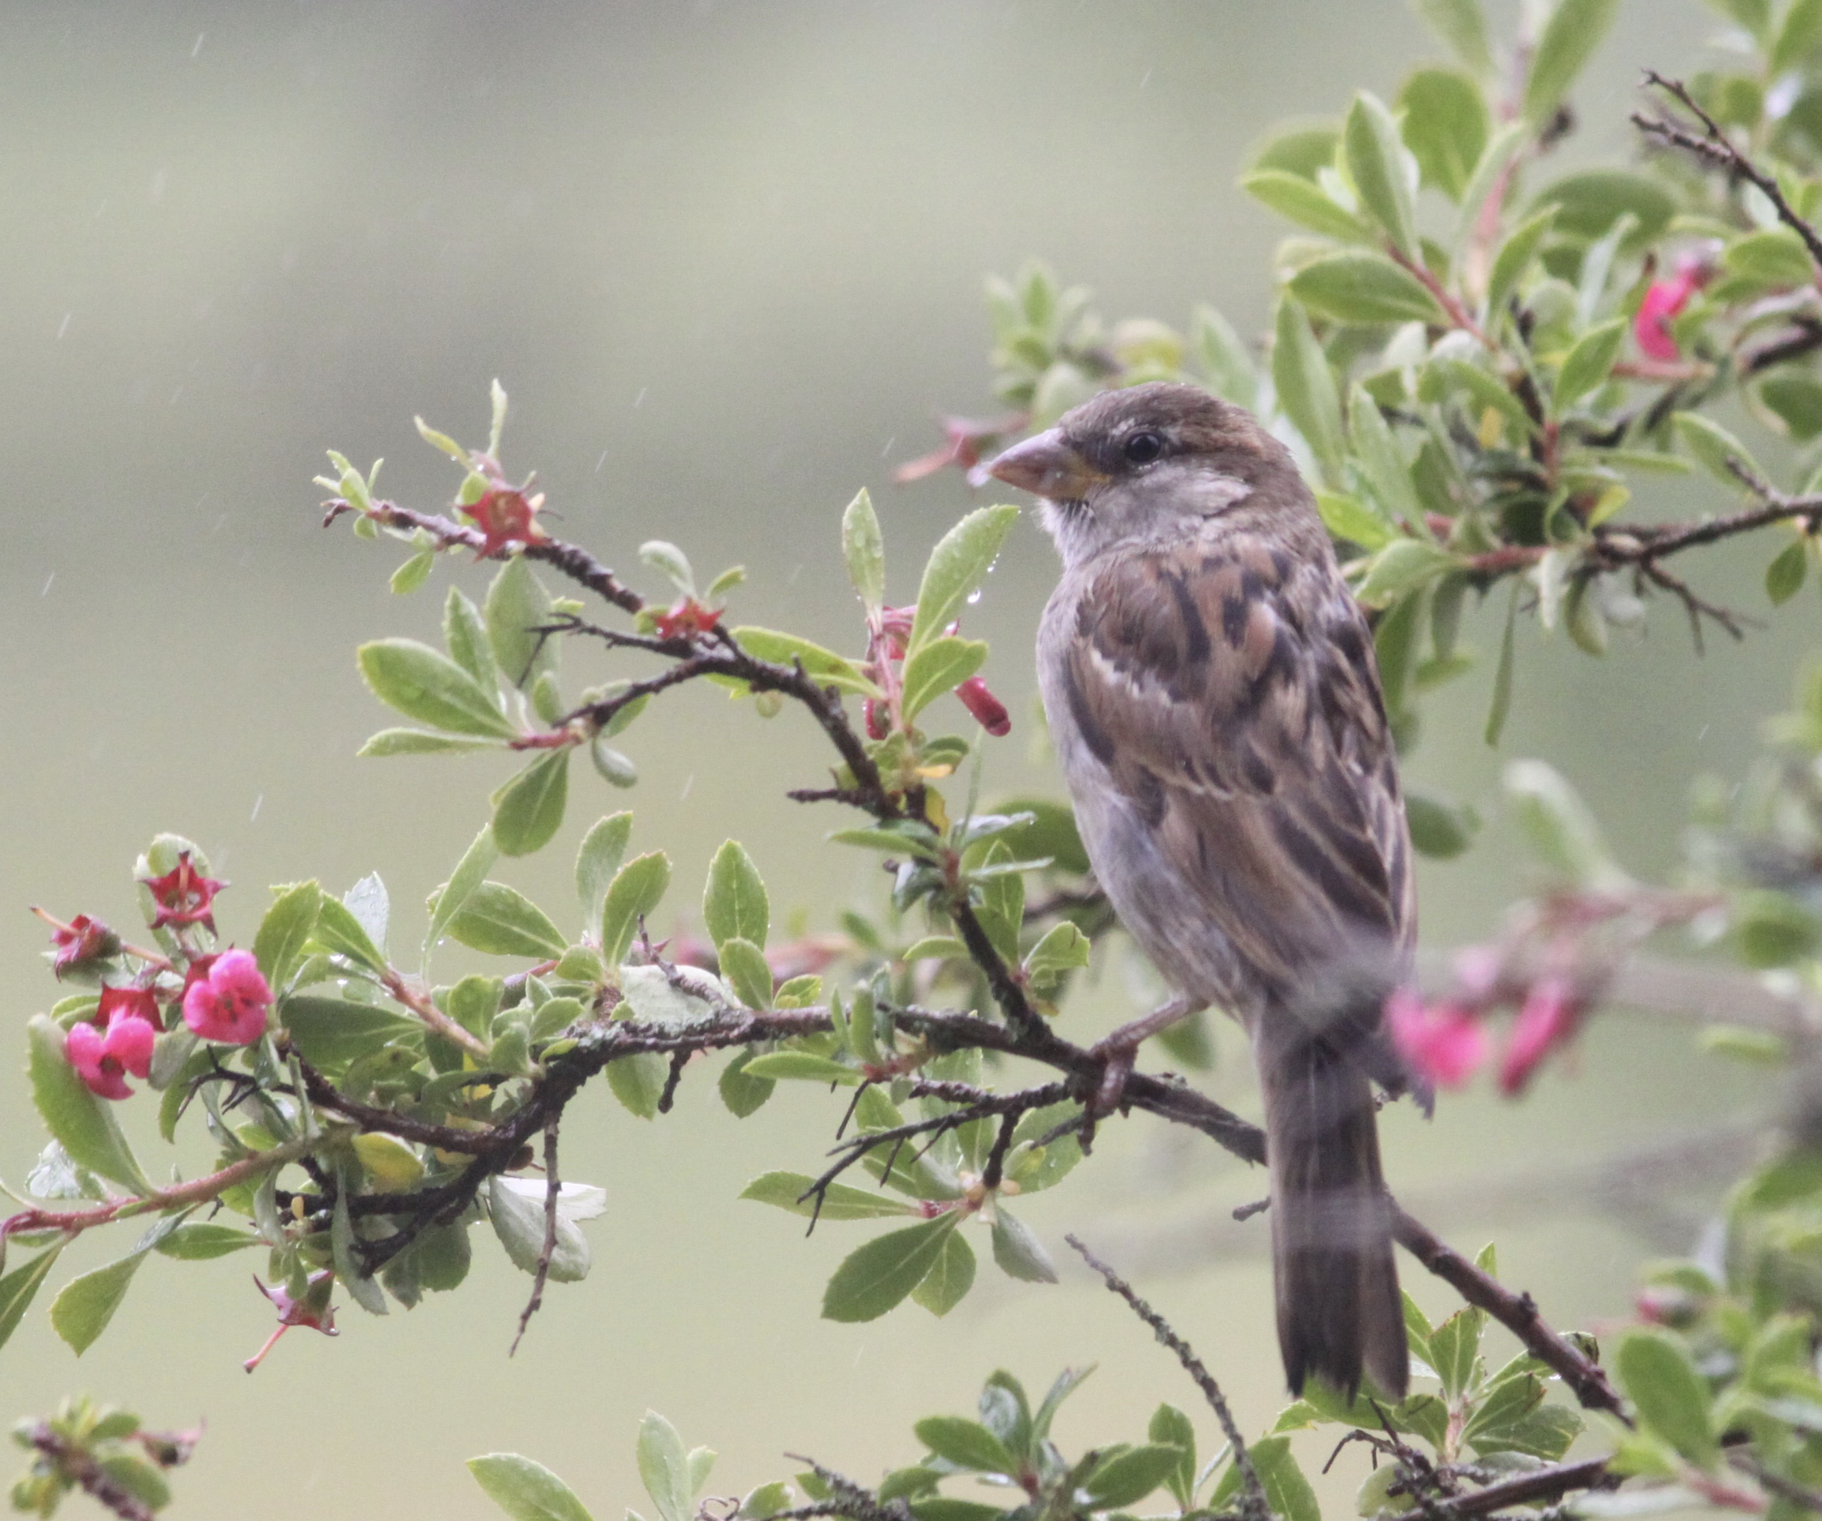

“In order to see birds it is necessary to become part of the silence.” (Robert Lynd)

Perhaps this advent, as we look forward to a Christmas that may look very different from last year, it could be an opportunity to connect through nature with something outside ourselves that I as a Christian would call God. But whether you see it the same way as me or not, being in touch with creation throughout the seasons can be a truly life-giving thing – go on – get out there and give it a go. And do feel free to send me any pictures or let me know how it's going – I'd love to hear from you!

St Francis, a Christian 800 years ago, talked about all of creation being our brother and sister because we all come from the same source. he cared about all of creation because he believed that every part of it, people, animals, plants comes from God. Many Christians today talk about the connection they feel with God when they are out in nature, and many people who are not Christians also talk about being outdoors giving them a sense of connection with something outside themselves that makes them feel truly alive.
hilary.bond@me.com

