“ Roman Rd” Walk

I thought it might be useful to put together a few notes as background information to this planned walk. Please don't hesitate to ask me or Sally for more details if you'd like any points to be expanded

Sally & Chris

It is axiomatic that all roads or tracks run, or ran, from somewhere to somewhere for a reason. Be they Neolithic trackways of logs as in the Somerset levels, or Bronze Age, Iron Age, Roman, or Medieval in date. They fall out of use when the reason for their existence disappears, and frequently become mere footpaths. Our countryside is a maze of them.

In my paper on Old Horspath, I mentioned (on page 45/6, printed below) a possible branch road or track leading from the main Roman road from Dorchester to Alchester that runs close to Horspath Parish. I felt that this branch road might possibly aiming towards the two Horspaths; and maybe even beyond. The reason for our walk is to familiarise ourselves with the environment surrounding this road or track and evaluate and debate its significance in the long history of Horspath Parish.

The primary evidence for this road is a note posted in 1895 by Percy Manning, an indefatigable collector of local archaeological finds, in the Berks, Bucks and Oxon JournalVol 28, published in 1898 headed: “Notes Archaeology of Oxford and Its Neighbourhood” (note XXXIV. Pp27ff) Here's an extract from his paper:-

“Roman pottery is often found in the brickfield on the north side of the old road over Shotover Hill, just at the western end of the hill.” (See 1945 aerial photograph below.)

(NB:The brickfield in question was situated on the north side of where the Old Road bridge over the Eastern Bypass now is. It was completely destroyed in the making of the bypass, as was most of the Roman road itself as far down as the southern side of Open Magdalen Wood. It is still extant in the bed of the small brook on the Brasenose Allotments, and as a significant earthen bank behind the industrial estate on Pony Road. CJP)

“In the bank on the north side (uphill; CJP) of the brickyard, is a section cut through a bed of stones some twenty feet in width, diminishing from a thickness of about one foot in the middle to almost nothing at the edges. It is evidently a road. It lies over 100 yards east of the line shown on the ordnance survey map as that of the Roman road from Dorchester to Alchester. The course of this road is by no means clear at this point, and it is possible that the surveyors have made a mistake in their line, and laid down the road too far to the west. If, however, the ordnance map is correct ( NB: it is correct, as the Eastern By-pass building work proved. CJP), we must assume that the road shown in the section is a branch road leading up Shotover Hill, possibly to a villa, which remains yet to be discovered. A similar branch road at Beckley, Oxon, about four miles north on the Alchester road, was noticed and described some years before it received an explanation, in the discovery of a villa to which it led some half-mile from the main (Roman; cjp.) road.

About 600 yards east of the brickfield, on the northern slope of the hill, more Roman pottery was found about two years ago by some men digging sand.”

This branch road leaves the main Roman Rd about 200 yards beyond the present Old Rd bridge over the eastern by-pass on the uphill, ie. eastern side, and would appear to be heading toward The Ridings and thence perhaps either to a villa somewhere near Westhill Farm or along The Ridings (?), or continuing to Lower Horsepath and then possibly to Old Horsepath, or both: or neither! See overview below:

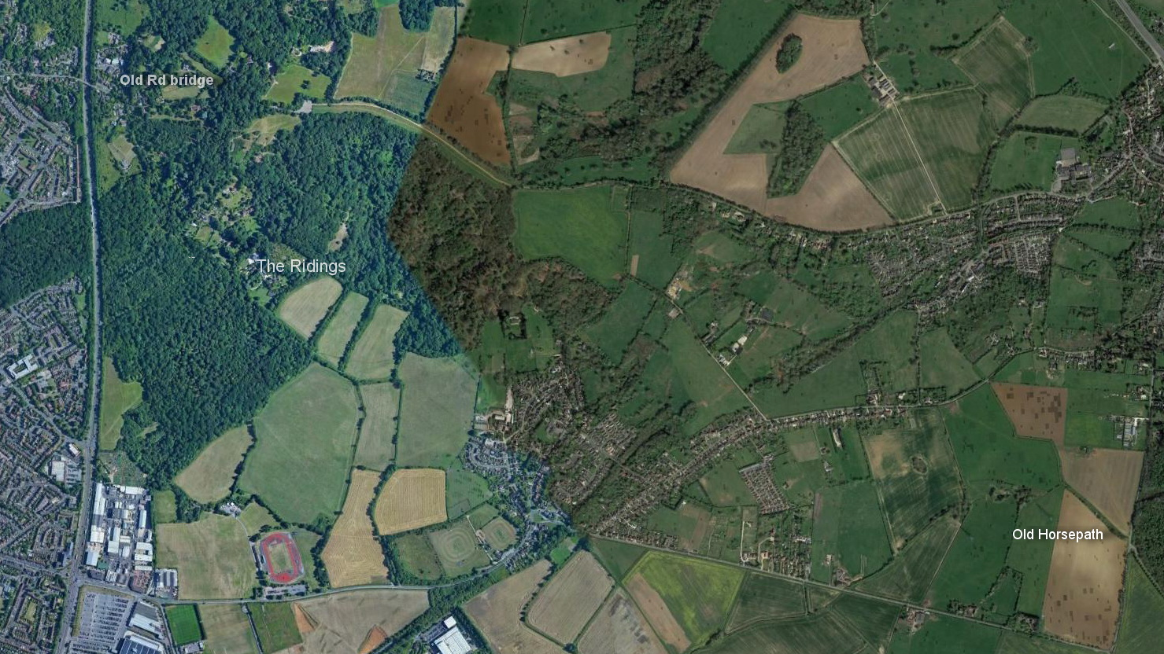
Route in 2018

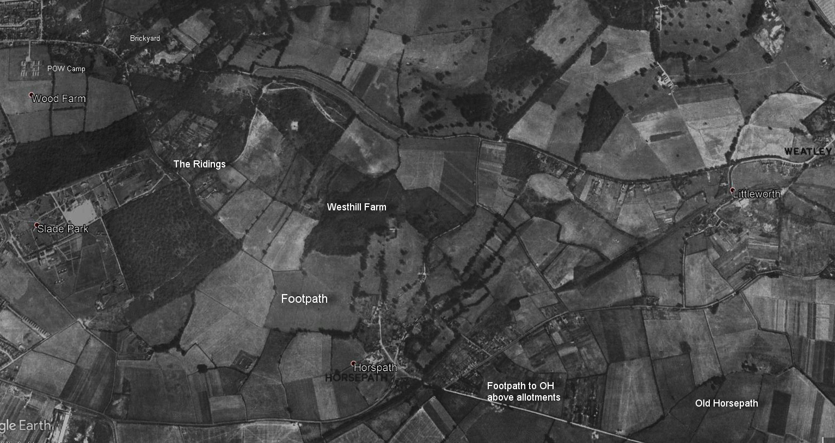
In 1945

It is worth noting that there was also another Roman branch road discovered during the building of the bypass on the opposite side of the main Roman road by Open Magdalen Wood, leading off westward through what is now Wood Farm Estate, and heading toward the extensive Roman kiln-field on the site of the present Churchill Hospital.

To add to the local Roman road record, Oxoniensia for 1960 (p.132) noted that during the building of the new gasworks at Garsington:- “two adjacent metalled road-surfaces on the line of the Roman road from Dorchester to Alchester, the westerly 15ft wide and at a higher level than the easterly which was 35ft wide, were seen in the connection trenches for the new gasworks. The surfaces were 5ft apart and of limestone gravel and rubble. The former footpath straddled them” .

The westerly one was probably a branch road leading off to the Roman kilns now under Blackbird Leys; the easterly one being the main Roman road. The ceramics traffic along this road in the mid to late 4th century must have been quite a sight!

The current village footpath extensions of the trackway from The Ridings down to modern Horspath are: across the fields below Westhill Farm to Manor Farm, then across Ford's Close to the Queen's Head via an alleyway ; then up to Butts Road and across to Gidley Way.
However, a more logical route, prior to the building of the Manor House sometime shortly before 1513 when Old Horsepath would have no longer existed & the track redundant, would have been through the land usurped by the Manor House (now approx Wrightson Close) and straight across to Gidley Way.) Thence through a footpath between two bungalows -now blocked with rubbish - on Gidley Way, across the new vinyard (footpath also closed), along the still extant track above the Horspath Allotments, then behind the gardens of the houses on Cuddesdon Road where a service road still existed until recently, and thence down to the Hollowbrook and up to Old Horsepath.

Maybe these are all a simple coincidence, but footpaths are tenacious and so often prove to have a very long history indeed, as Peter Ewart will confirm.

Food for thought anyway and the implications of this (if proven) would be rather interesting indeed. So how do we prove it? Views?

Caveat: This proposed route, apart from being much shorter than any other, may have been a preferred route from Headington Quarry to Horspath village in medieval times, before the climate worsened around AD 1350 and the fields below Westhill Farm became a quagmire in Winter.
The route would have been ideal for heavy carts of building stone (no hills to climb) for the church, built in the 1200s, and other older buildings in Lower (modern) Horspath, compared to the alternative route over Shotover to the Wheatley quarries.
So we might simply have the remnants of a stone-carrying track. But if so, why the apparent footpath extension to Old Horspath?

Given that Oxford itself had no great concentration of population in Roman times – a few scattered farms are all that have been found so far – then it follows that the Old London road over Shotover would have been a later addition, probably 9th or 10^{h} century AD after Saxon Oxford was laid out, thus the direction of the branch road under discussion is a clue to its final destination, rather than a link to the later “old” road over Shotover.

We know that the main Dorchester-Alchester road passed close to the Roman kilns next to Open Brasenose, and there is crop-mark evidence of a track leading from those kilns up towards the large Roman kiln field on the top of Shotover, close by the present reservoir. (See air photo below)
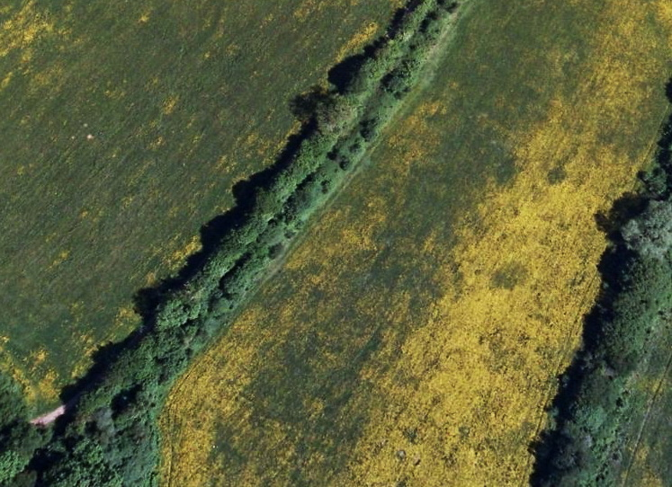
This road parallels the modern tarmac road leading up to Westhill Farm. Note that a number of what appear to be hut circles lie adjacent to or on this old road. That it is a road was confirmed to me by the late John Heritage – Bob Walker's ploughman for many years. He told me that in ploughing this part of the field he frequently turned up quantities of rubble.

So it seems probable that the output from the upper kilns would have been transported down to the Open Brasenose area for onwards transportation along the main Roman road.

However, Manning's suggestion that the branch road might lead to a Roman Villa is extremely interesting, to say the least. Perhaps a separate exercise in villa-hunting is needed? Could be fun!

Chris 15/08/2018

