Consecration and Rededication of Cuddesdon Bells
By Bishop Humphrey Southern
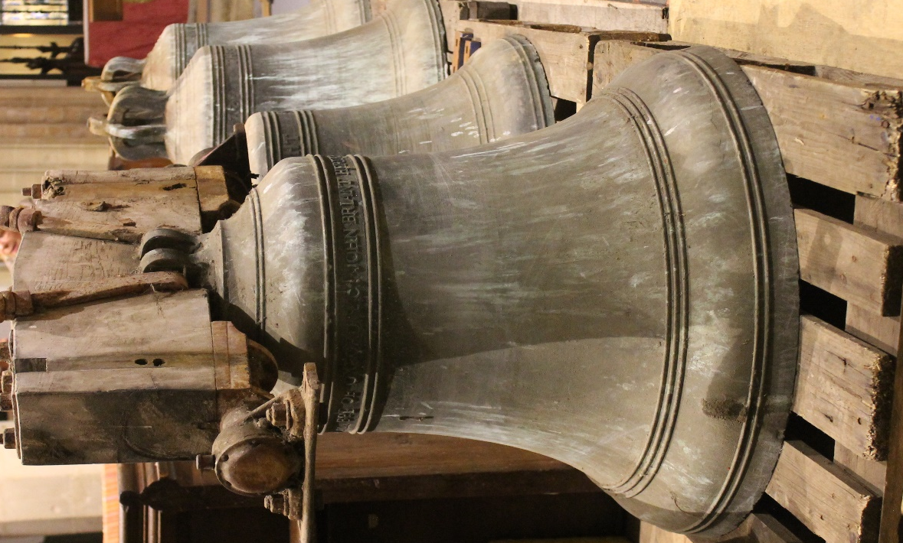
All Saints’ Church, Cuddesdon
Saturday 21st April at 6 pm

Order of Service

Welcome and Introduction

Brothers and sisters, we are met here to consecrate and rededicate these bells, to commit to God the work which they shall do in years to come, to ask God’s blessing on all who shall ring them and to ask that all who hear them shall lift up their hearts to God.

Let us thank God for the craftsmen who during the centuries have cast and restored bells in this and other towers throughout the land; for the ringers who in times past have rung these bells; let us pray also for the ringers throughout this land and overseas, that through their art, we may in faith be one for evermore.

Let us pray that the message of the bells may bring joy to the sad, penitence to sinners, and encouragement to the faithful and all who seek truth. In the song of these bells, may we find peace in our souls.

These prayers and praises we humbly offer up to God in the words which Christ taught us, saying:

Our Father, who art in heaven,
hallowed be thy name;
thy kingdom come;
thy will be done;
on earth as it is in heaven.
Give us this day our daily bread.
And forgive us our trespasses,
as we forgive those who trespass against us.
And lead us not into temptation;
but deliver us from evil.
For thine is the kingdom,
the power and the glory,
for ever and ever.
Amen.

Lesson

1 Chronicles 29: 9-17

Psalm 150

Praise God in his temple
Praise his strength in heaven

Praise him for the mighty things he hath done
Praise his extreme greatness

Praise him with trumpets
Praise him with the harp and lyres

Praise him with the drums and dancing
Praise him with the harps and flutes

Praise him with the cymbals
Praise him upon the loud cymbals

Praise the Lord, all living creatures;
Praise the Lord

Glory to the Father and to the Son and to the Holy Spirit:
As it was in the beginning, is now and shall be for ever. Amen.
Lesson

1 Corinthians 13: 1-3.

The Bishop sprinkles the bells with water.

Consecration of the Treble Bell

Bishop In the name of the Most High God, Amen. I anoint this bell for the healing of Christ’s faithful followers, that those who hear it shall be helped and strengthened in soul and body, through Christ the Lord of earth and heaven. Amen

The Bishop takes the oil for the sick and moves round the bell from North to East making the sign of the cross on the lip of the bell.

Bishop O Christ you are the great exemplar of all divine virtue. Pour down your blessing upon this bell, that its voice may arouse the hearts of Your faithful to the discernment of, and the will to copy, Your + strength, Your + Wisdom, Your + beauty, Your + justice, Your + devotion and Your + guiding power, so that Your servants being of grace made perfect in You, may attain the glory which You have ordained for them. O God who lives and reigns with the Father and the Holy Spirit, one God throughout ages of ages. Amen

The Bishop takes the oil of chrism and anoints the four points inside the lip of the bell saying:

Bishop To the Glory of God Most High. I solemnly dedicate this bell. May its sound peal forth ever to the praise of God and the blessing of those who hear it.
The Bishop makes five large crosses in the air over the whole bell and continues:

Bishop May it be + hallowed and + consecrated to God’s service for ever, in the name of the + Father and the + Son and the Holy + Spirit.

The Rededication of the Bells

Bishop Almighty God, we offer to you all the work that has been undertaken to restore these bells – Bless, Sanctify and Hallow all that has been done in this church, Bless with Your grace and skill all who ring here, and grant that the message of these bells may lift the hearts of all who hear them, through Jesus Christ our Lord. Amen.

Grant, O Lord, that whosoever shall be called by the sound of these bells to this House of prayer may enter into Your Gates with thanksgiving and into Your Courts with praise, through Jesus Christ, our Lord. Amen.

The Blessing of the ropes

The ropes are sprinkled with water then the Bishop says:

Bishop Almighty and everlasting God, these ropes will toll the bells with we have dedicated to You. Those who ring the bells call the faithful to service, and remind your people of Your omnipotent presence in their community. Without these ropes the bells have no voice; with them the hands of the ringers bring the sweet sound of Your presence to be heard by all. May these ropes of many threads be like your church: each one, like us, insufficient alone, but bound together made strong in faith and in service. May these ropes connect us to your Spirit in the same way they connect the bell to those that ring them. Amen

The Ringers’ Prayer

All ringers present say together:

Gracious Lord, source of all skill and beauty, who hast entrusted to us the ringing of Your bells, give us the needful skill and grace for the faithful performing of our art, that the sound of the bells may awaken in the hearts of all who hear then the desire to worship You in spirit and truth; through Jesus Christ our Lord. Amen

The Blessing and Dismissal

Bishop Go forth into the world in peace; be of good courage; hold fast that which is good; render no one evil for evil; strengthen the fainthearted; support the weak; help the afflicted; honour everyone; love and serve the Lord, rejoicing in the power of the Holy Spirit and the blessing of God Almighty, the Father and the Son and the Holy Spirit be with you this night and for evermore. Amen.

THE SIX BELLS OF ALL SAINTS CHURCH, CUDDESDON.
During the Reformation in the short reign of Edward VI, an inventory of Church bells in England was taken (Cuddesdon included), and the entry read: “4 belles and 1 litle bell). None of these bells from the 1550s now exist, and they would have been replaced by the three bells made in 1617 by Henry Knight of Reading, which are now the second, third and fourth bells of the present ring; the treble was cast in 1795 and may also have originally been a Henry Knight bell. Later there was added the fifth of 1677 and the tenor of 1709, but these were eventually replaced by the Whitechapel fifth and tenor of 1863, which are here today. The six bells hang in the central tower, hung for “full circle ringing” in a wooden frame with wheels and ropes, to enable ringers to ring the bells from a ringing room high in the tower. In recent years they have become somewhat challenging to ring, so that hearing these lovely bells has become a rare occurrence. Thus the decision was taken as part of the overall restoration project at All Saints to remove the bells, and have them restored by the Church Bellhangers, Whites of Appleton. The bellframe is to be reinforced, and five of these bells will be rehung; the one that will not be included in the six is the present treble (lightest) bell, which has been found to be porous. Thus a brand new treble bell was cast at the famous Whitechapel Bell Foundry in 2017 – on the very last day that the foundry cast bells after some five hundred years of bell casting ! This treble bell is inscribed “To the Glory of God and in loving memory of Dr. Christopher Ware, 1955 – 2006”. Very few bells exist in England that are not similarly dedicated, and below is a list of the Cuddesdon bells with their founders names, dates and weights. The oak frame dating from the seventeenth century was renovated in 1949 by Messrs. R. White & Son, who then rehung the treble, fifth & tenor with new gear, type E. The fittings of the remaining bells, type C, date from the 19th. century.
THE BELLS: WEIGHT, DIAMETER, KEY, DATE of CASTING, FOUNDER & INSCRIPTION.
Bell | Weight  CWT-QR-LB | Diameter  INCHES | Note | Cast | Founder | Inscription
1 | 5½ cwt | 31.63 | D | 1795 | John Briant | THE GIFT OF DR. E. SMALLWELL BPT OF OXFORD & Co. IOHN BRIANT HERTFORD FECIT AN : DOM : 1795.
2 | 6¼ cwt | 31.50 | C | 1617 | Henry Knight I | + HENRX KNXGHT MAdE MEE X6X7
3 | 7 cwt | 33.88 | B♭ | 1617 | Henry Knight I | + HENRX KNXGHT MAdE THXS BELL X6X7
4 | 8 cwt | 35.25 | A | 1617 | Henry Knight I | + HENRX KNXGHT MAdE MEE  ANO X6X7
5 | 9-3-19 | 39.00 | G | 1863 | G Mears | G. MEARS & CO. FOUNDERS LONDON 1863
6 | 14-2-16 | 43.88 | F | 1863 | G Mears | G. MEARS & CO. FOUNDERS LONDON 1863
Saunce | ½ cwt | 13.00 | E | 1748 | Thomas Lester | 1748

(Brian Lowe, Acting Tower Captain, All Saints, Cuddesdon. October 2017).

