Welcome to Experience Easter

A series of six interactive prayer stations to help you to encounter the story of Easter

Easter is the time when Christians everywhere remember what happened to Jesus in the last week of his life and after his death.

The Easter story begins with Palm Sunday. On a bright spring day Jesus and his twelve disciples went to the great city of Jerusalem for a special festival called Passover. The festival celebrated the time long ago when God had led the people from slavery to freedom.

As Jesus rode into Jerusalem on a donkey, the crowds went wild. They threw their cloaks in the road and pulled down palm branches to wave. “God bless the king who comes in God’s name,” they cheered.

But some of the leaders were angry, “What does all this mean?” they grumbled. “He’s going to cause trouble. We need a plan to get rid of this Jesus.”

To celebrate Passover, Jesus and his friends met together for a special meal. Jesus took a bowl of water and a towel and knelt down to wash and dry the disciples feet. “If you are wondering what all this means,” said Jesus, “it means I want you to be ready to serve others in the same way that I have served you.” Then Jesus broke bread for them to share and poured wine for them to drink. “When you eat bread and drink wine like this,” he explained, “you will remember me.”

Later that night Jesus went by himself to a quiet garden to pray. Some soldiers came to arrest him and all his friends ran away and left him. The soldiers took Jesus to the leaders who questioned him. People came and told lies about him. They laughed at Jesus and claimed that he deserved to die.

In the morning they took Jesus to the Roman Governor, Pontius Pilate. He thought about it, but could not work out fro himself what it all meant. He let the people decide for him. His soldiers took Jesus away to crucify him.

After Jesus had died, his body was laid in a tomb into the rock in a beautiful garden.

Very early on Sunday morning some women, who were friends of Jesus, went to visit the tomb. They found it open and empty and by it stood and angel in bright, shining clothes. “What does it mean? Oh what does it mean?” sobbed the women. “Do not be sad,” answered the angel. “It is good news. It means Jesus is not dead. He is alive!”

At Easter time Christians remember the events that you will hear about today and celebrated with great joy because we believe that Jesus rose from the dead and is with them still.

As you make a journey around the church, visiting the different parts of the story, you will be able to find out why Easter is such a special time for those who follow Jesus.

You may like to wonder yourself just what it all could mean.

Station One – down the central aisle to your left as you enter the church

Hopes and Dreams – The story of Palm Sunday

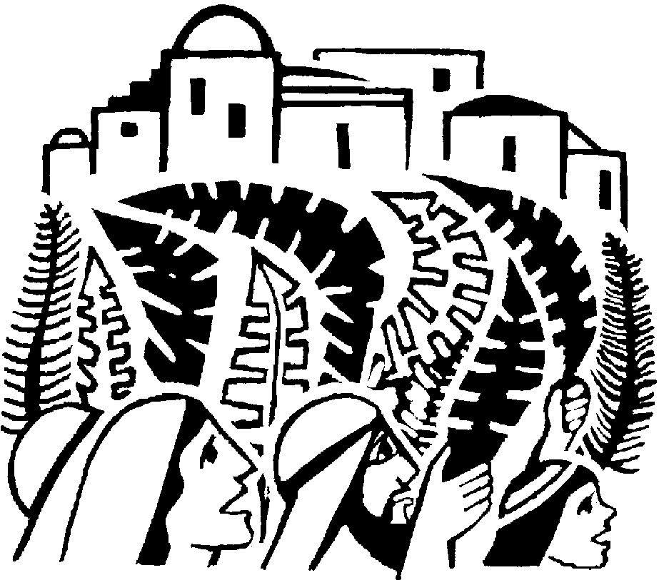We all dream sometimes about how things could be different and how our lives could be better. As you read the story think about your hopes for the future.

When Jesus came into the great city of Jerusalem the crowd was excited and restless. Many had heard of Jesus’ teaching and miracles. They longed for a leader who would help them drive the Romans from their land so that they could live in peace and prosperity. As Jesus rode through the city gates on a young donkey the people cheered and praised God. “Blessed is the king who comes in the name of the Lord”. As people began to throw their cloaks and palm leaves onto the ground to pave the way for Jesus, their hearts were full of expectation. Some of the religious leaders grumbled at Jesus but he told them that even if the crowds were silent the very stones would cry out.

What do you think Jesus meant when he said “If the crowds were silent the very stones would cry out”?

Choose a stone and imagine it represents a dream or hope for the future, then place it in the cairn beneath the cross at the end of the road.

Station Two – at the font in front of the north door

Servant King – Jesus washes the disciples’ feet

‘Servant’ and ‘King’ make us think of different types of people.
Why do you think that Jesus is sometimes called the ‘Servant King’?

Jesus lived in a hot and arid country. Most people travelled from place to place on foot. It was the custom to welcome visitors by washing their feet in cool, clean water. Normally a household servant did this.
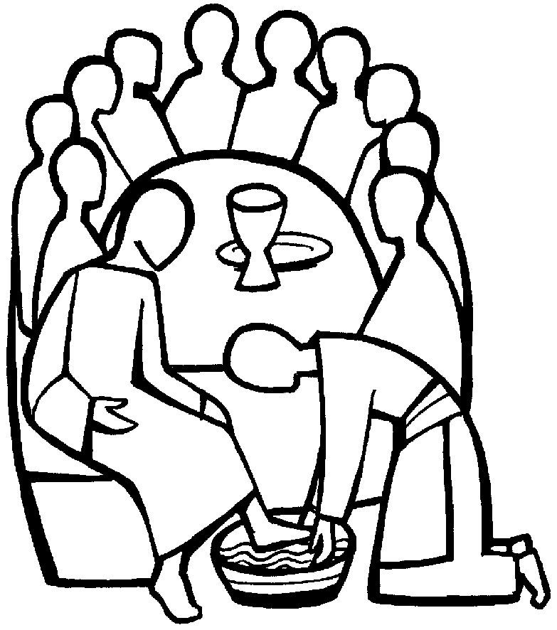
When Jesus invited the disciples for supper in the upper room, they were surprised by what happened.

Jesus took off his outer clothing and wrapped a towel around his waist. After that, he poured water into a basin and began to wash his disciples’ feet, drying them with the towel.

When he had finished washing their feet, he put on his outer clothes and returned to his place. “Do you understand what I have done for you?” he asked them, “You call me ‘teacher and Lord’, and rightly so, for that I what I am. Now that I, your Lord and teacher, have washed your feet, you should also wash one another’s feet. I have set you an example that you should do as I have done for you.”

What do you think Jesus meant when he said “I have set you an example”?

How can the followers of Jesus care for one another today?

A prayer by St Teresa of Avila:
Christ has no body now on earth but yours:
Yours are the only hands with which he can do his
work,
Yours are the only feet with which he can go about the world,
Yours are the only eyes through which his compassion can shine forth upon a troubled world.
Christ has no body now on earth but yours.

Dip your finger into the water in the bowl and make the sign of the cross on the palm of each hand and pray silently that God will help you to serve others in a special way this Easter.

Station Three – in the centre of the church

Remember Me – The Last Supper

Do you have any special objects that help you remember an important time in your life?

When Christians meet together they will often share bread and wine to remember the last meal that Jesus had with his friends before he died.
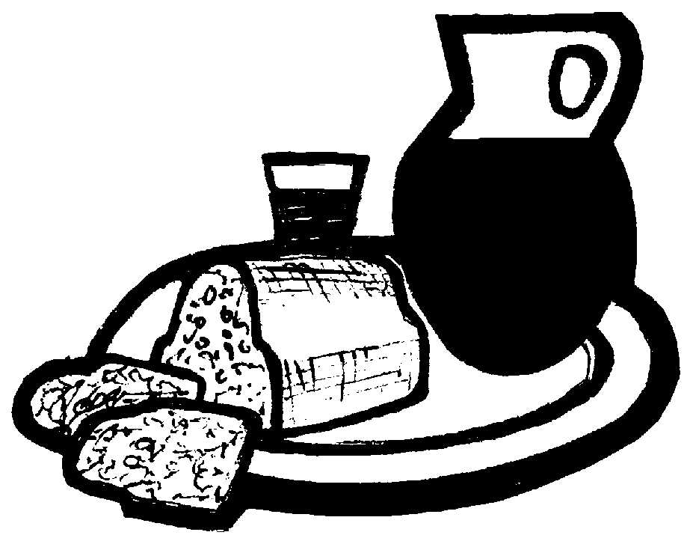
On the night before he died, Jesus had supper with his friends.

He took some bread and thanking God for it he broke the bread.
Jesus gave the bread to each of his disciples and said “Take, eat, this is my body which is given for you, do this to remember me”.

If you would like to, take a piece of bread and as you eat it, think of something you remember about Jesus.

Station Four – in the north chancel window

Alone – In the Garden of Gethsemane

Often people feel most alone after darkness falls and when it is very quiet.

Can you remember a time when you felt very alone?

Jesus knew that soon the soldiers would come to arrest him and he would be sentenced to death. He went to a garden, called Gethsemane, with his friends and asked them to keep watch for him while he prayed to God to help him. But, his friends were tired and they fell asleep. In the darkness of night Jesus felt very alone. Even so, he trusted himself to God’s care.

Draw a shape, figure or object that reminds you of a time when you were lonely and afraid.

God says:
“I have called you by name, you are mine.” (Isaiah 43.1)
“I have loved you with and everlasting love….” (Jeremiah 31:3a)
Jesus says:
“Peace I leave with you; my peace I give to you. Do not let your hearts be troubled and do not be afraid.” (John 14:27)
Station Five – at the altar

Sharing our Sorrows – The Crucifixion

What are your thoughts as you look at this station?

Soldiers led Jesus outside the walls of Jerusalem to Golgotha, which means the place of the skull. A crown of thorns had been placed on his head. They nailed him to the cross and fastened a notice to it that read ‘Jesus of Nazareth, the King of the Jews’.

While they waited for Jesus to die the soldiers cast dice to see which one of them would Jesus’ robe for themselves. When Jesus became thirsty the soldiers offered him a sponge soaked in vinegar. At three o’clock that day Jesus died.

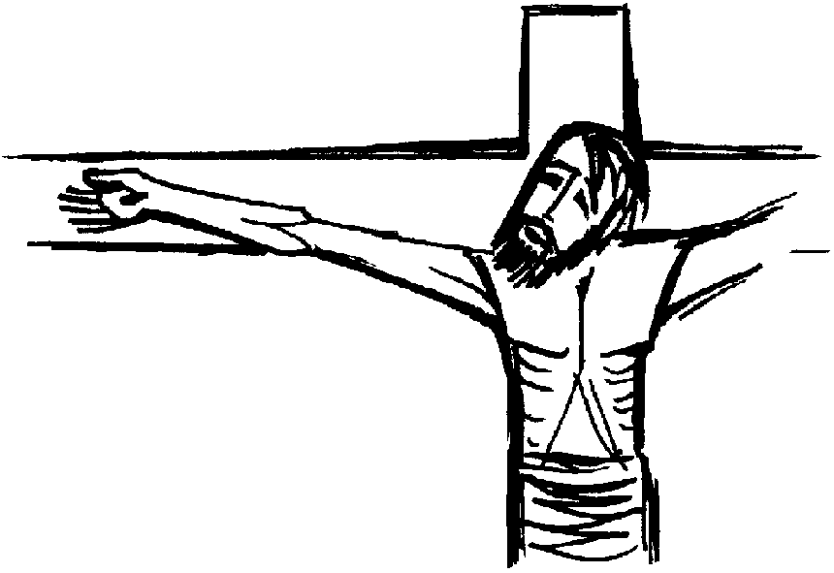

The cross reminds Christians of the death of Jesus but because he rose again the cross has also become a sign of hope for anyone who is suffering.

Write a prayer for someone or somewhere you know where there is suffering today and place it at the foot of the cross.

Dear Jesus
Help all the people we have named and anyone else who is sad or suffering today to know that you are with them and love them very much.
Amen.
Station Six – in the south aisle

Resurrection – The Empty Tomb

Angels proclaimed the birth of Jesus and after his death on the cross it was an angel who told the women that Jesus was alive. Do you think angels still visit us today?

Each year at Easter, Christians build a garden and empty tomb like this one in their churches.

After the Sabbath, Mary Magdalene and two other women set out at dawn to visit the tomb where Jesus had been laid. As they reached the entrance, they were startled by the dazzling figure of an angel, who said “Do not be afraid, for I know that you are looking for Jesus, who was crucified. He is not here. He has risen, just as he said. Come and see the place where he lay.”

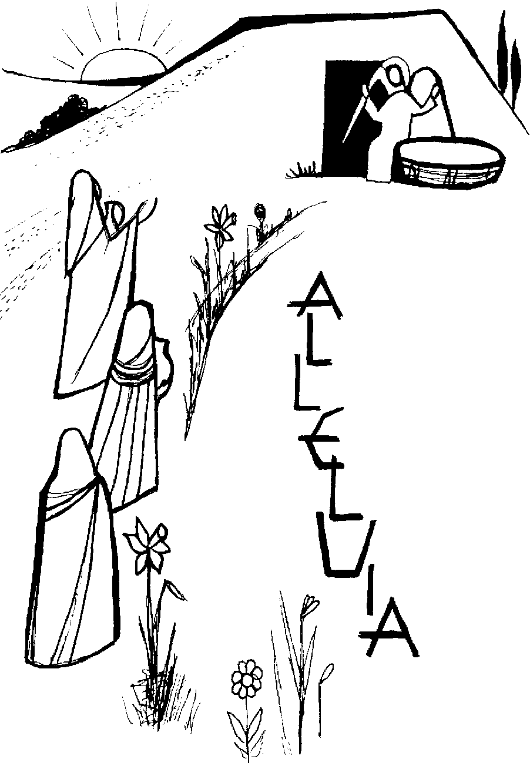

Like the women, Christians look into the empty tomb to remember that Jesus, God’s son, was crucified but after three days rose from the dead. They believe this is the greatest miracle the world has ever known.

How do you think the women would have felt when they heard the angel’s news?

Jesus was put to death on a cross like a criminal, even though he had done nothing to deserve this awful punishment. But as we have heard the Bible tells us that on the third day Jesus was raised to life once again, giving his followers the hope that death is not the end of everything. In fact, in some ways it is just the beginning.

This is why we celebrate Easter by giving and receiving Easter eggs, a symbol of new life and hope for the future.

Please do take a card and Easter egg.
We hope you have enjoyed Experience Easter, please leave your donation towards the costs of the event and the work of the church on the plate or in the wall safe, thank you.
Written by Shahne Vickery, Catherine Coster, Janet Lunt and Carolyn Wright and adapted by Emma Pennington
Copyright Diocese of Gloucester.

