Services for Lent and Easter For all the Family

20th March Palm Sunday Mothering Sunday 6th March Lent and Easter across
9.30 am St Mary’s and All Saints’ 9.30 am St Mary’s and all Saint’s the Benefice
11 am St Giles’, Horspath Family Communion
Procession of Palms and 11.00 am St Giles’, Family Service
Reading of the Passion with posies for mothers

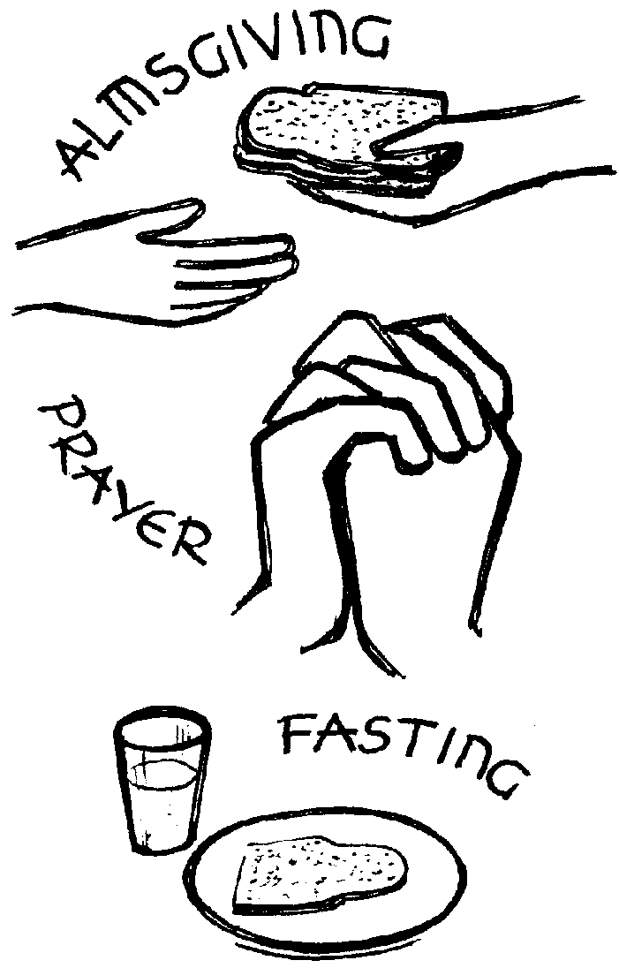
Holy Week Stepping Stones Workshop
9am Morning Prayer with reflection in Garsington School
At St Mary’s, Garsington on Good Friday
from 10 am til 12 noon
24th March Maundy Thursday
7pm at The Hub, Horspath Messy Church
Agape supper with communion 14th February and 13th March
3.30 to 5 pm in Cuddesdon Village Hall
25th March Good Friday
9 am Morning Prayer at St Mary’s 27th March Easter Day
10 am Reflection Time in St Giles’ 9.30 am Easter Communion with
Followed by coffee in the Hub Egg hunt at St Mary’s and All Saints’
1 to 2 pm At the foot of the Cross 11 am Family Time: The Easter Garden
With Julian of Norwich with Easter Egg Hunt at St Giles’
A service of meditations and silence

at St Mary’s, Garsington
3 pm Good Friday Liturgy
at All Saints, Cuddesdon

A Time for Study A Time for Prayer A Time to Give

There are a number of Lent groups Julian Group on 11th Feb & 10th March
Meeting across the Benefice: at 2 pm in the Edward King Chapel for
reflection and 30 minutes of prayer.
The York Course Lent Group For more information please go to
which is looking at The Psalms: Prayers www.thejulianmeetings.net
for today’s church.
Wednesdays 10.30 to 11.30 noon Lent Quiet Day on 17th February
At 43 Gidley Way, Horspath in the Edward King chapel,
Hosted by John Llewelyn led by Canon Neil Heavisides,
For information contact David Rule former Precentor of Gloucester Cathedral
on 8731609 The full timetable for the day is: Soup Lunch
9.15-10am Morning Prayer and Address I From 12 noon to 2 pm on
St Mary’s Lent Book Group 12noon-1pm Eucharist and Address II Saturday March 5th
are reading I Am With You Lunch at the Bat and Ball Kindly hosted by Carol and
by Kathryn Greene-McCreight 3.15-4pm Evening Prayer and Address III Cliff Shuker at 20a The Hill,
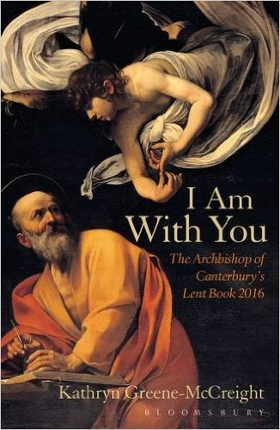
The book examines the 4pm Tea in the common room Garsington, Lunch £6,
biblical portrayal of God's Raffle, stalls and more

presence among Proceeds to local charity &
us as light in darkness. St Mary’s, for numbers
Wednesdays 8 to 9.30 pm contact Tina on 361429
At The Rectory,
17 Southend, Garsington Jam Jar Challenge
Hosted by Emma collect as many coins as you
Beginning 17th February can for your church to win
for five weeks the prize

