Christian Giving Pledge

& Gift Aid Declaration

We are seeking your help to resource our Church’s ministries in Horspath. They currently cost £454 a week to sustain. It helps us for 2015/16 if you can indicate the size of your offering.

NB. Only the treasurer will see these details.

In grateful response to God’s love for me and as a thanksgiving for the blessings He provides, I intend to give £ ………….

each week each month

each quarter each year

I would like to make my gifts by:

Standing Order the envelope scheme cheque

This offering will be: please delete as appropriate
an increase / continuation / decrease in my giving
a new start for me to give on a regular basis
with effect from …… / …… / …….

I am interested in leaving a legacy to St Giles’

I am a UK tax payer. Please treat all gifts I have made to the PCC of St Giles’ Church, Horspath since 6th April 2000 as Gift Aid donations.

Title …….. Christian name(s)…..……..……..………

Surname ……………………………………………

Address ……………………………...…………….
………………………………...………….
Postcode ………………...…………….

Signed …………………… Date …… / …… / ……

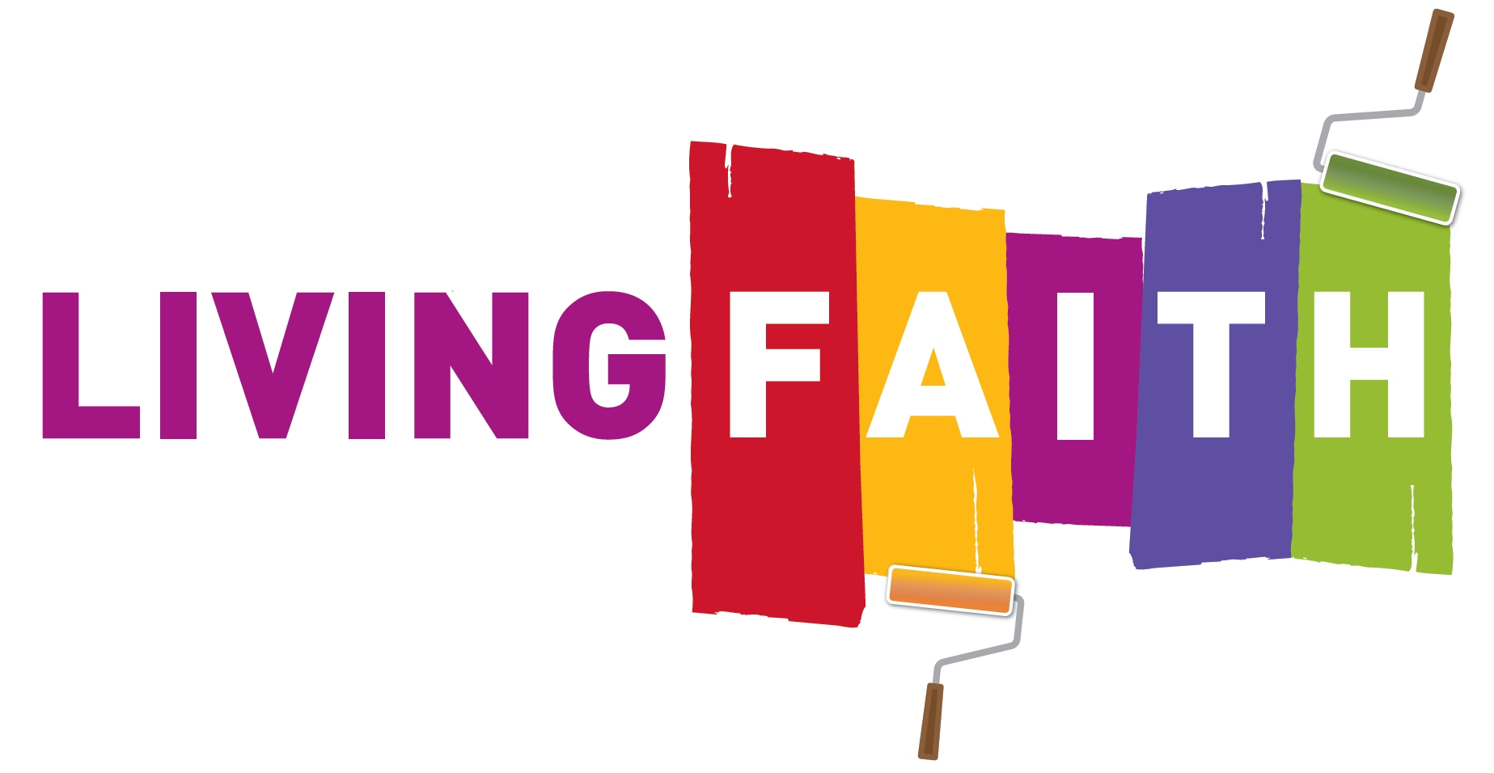

Living Faith encapsulates four values we try to live by as Christians:

Contemplative – attentive to God
As you therefore have received Christ Jesus the Lord… Colossians: 2.6
Devote yourselves to prayer… Colossians: 4.2
Creative – imaginatively releasing and harnessing all the gifts of all God’s people
We have gifts that differ according to the graces given to us Romans: 12.6
Let the word of Christ dwell in you richly… Colossians: 3.16
Continuous – rooted in scripture, faithful to the traditions we have received and seeking to give them fresh expression
Rooted and built up in him and established in the faith, just as you were taught… Colossians: 2.7
For I received from the Lord what I also handed on to you…
1 Corinthians: 11.23
Accountable – to God and to each other as we build for tomorrow as well as today
Keep watch over yourselves and over all the flock… Acts: 20.28
Render to God the things that are God’s… Luke: 20.25

Banker’s Order

To the Manager .…………………….… Bank/Bldg Soc
Address ……………………………………………….
………………………………………………..

Please pay to St Giles’ Church, Horspath A/C
at XX XX Bank plc
address XX xx
XX
XX
XXXXX

sort code XX – XX – XX
account number XXXXXXXX

the sum of £ ……. (…………………………………words)

every month/quarter/year until further notice commencing
on the …...(no.) day of …….………(month) …..…… (year)
My account name ……………….…..………….……
My account no. …….………….…
My sort code …... / ..… / …..
My address ………………….…………….……..…..
…………………………………………………..
…………………………………………………..

Signed ………………….………….. Date …………...……..

Changing a Standing Order

This order cancels any previous instructions in favour of
the PCC of St Giles’ Church, Horspath
next payable on …. / …. / ….

Signed …………………………… Date…………...…

Gift Aid

Do you pay income tax, or capital gains tax?

Do you support God’s mission through our Church’s ministries?

Do you want our Church to recover an additional 28 pence
for every one pound you give?

If you have answered ‘Yes’ to all these questions
you can make your gifts using the Gift Aid scheme.
(See Gift Aid Notes overleaf)

What do I need to do?
All that you need to do is to sign and date
the Declaration and fill in your full name, address
and postcode in block capitals. This enables
the Inland Revenue to identify you as the donor.
If you pay higher rate tax, you need to keep a record of the dates and sums of all gifts under the Gift Aid scheme and include them in your next Self Assessment tax return.

Is the information kept confidential?
You do not need to disclose details of your income
or tax affairs; these remain your private affair. Once signed, our church keeps the declaration. We are then able to recover tax on your gifts, at no extra cost to you.

How can I make my gifts?
- You can use the attached Banker’s Order to help us administer your offering more efficiently.
- You can give cash by asking for a supply of envelopes which carry a unique number. Only the person who makes the tax claims on behalf of our Church needs to know which number corresponds to each donor. The envelopes can be dated for each Sunday and provide a firm link between Giving and Worship.
- You can give using a cheque on your personal bank account and place this in the offering envelopes.

Gift Aid Notes

- Please notify our Church if you change your name or address whilst the Gift Aid Declaration is still in force.
- You can cancel the Declaration at any time by notifying our Church. We will then cease recovering tax from the Inland Revenue via the Gift Aid scheme.
- You must pay an amount of Income Tax and/or Capital Gains Tax in any one tax year at least equal to the tax that our PCC recovers on your gifts in the same tax year (currently 25 pence for each £1.00 you give). NB. HMRC will add an additional 3 pence on top of this 25 pence.

Higher rate taxpayers and those receiving tax rebates
- If you pay tax at the higher rate you can personally recover a further 25 pence for every £1.00 you give.
- Through a recent change in Self Assessment tax returns and tax rebates, you can now increase your support of our Church’s mission by designating St Giles’ Church as the recipient of your tax rebate (or a portion of it). By using the Inland Revenue’s unique reference number for our PCC (JAD24VG: St Giles PCC Horspath), you can not only direct your recovered tax to our Church but, because the Inland Revenue recognises this allocation as a further gift, they will add an additional 20% Gift Aid benefit. This could enable us to recover as much as 58 pence for every £1.00 you give.

For further details, please contact:
Mr Charles Gurden
PCC Treasurer
24 Spring Lane
Horspath
Oxford
Telephone: (01865) 873284 August 2015

Resourcing

God’s Mission



St Giles’ Church

Horspath

Christian Giving

& Gift Aid

We are part of the Benefice of
Cuddesdon, Garsington and Horspath
A group of neighbouring parishes

serving local communities

