Walking the Rectory Labyrinth
Summer 2017
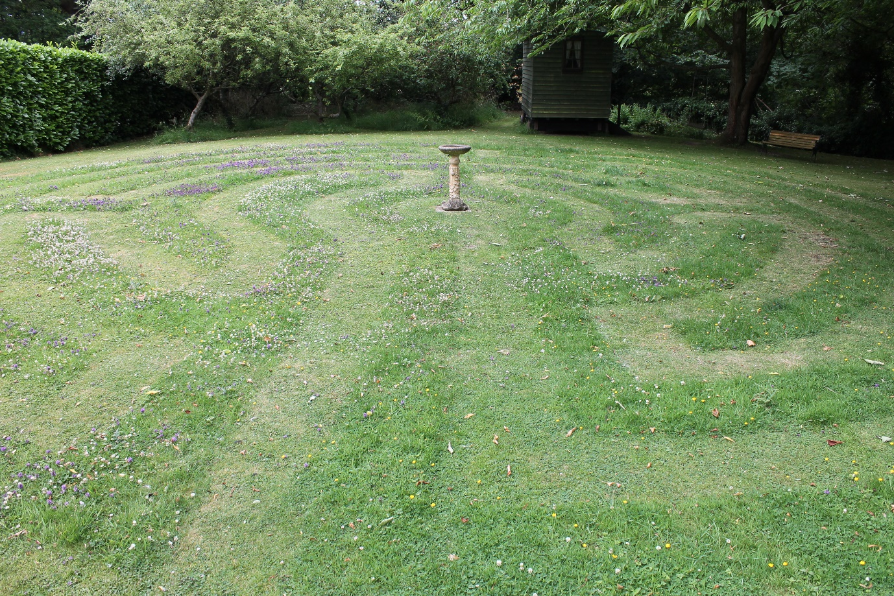

Stand at the crossroads, and look, and ask for the ancient path where the good way lies; and walk in it, and find rest for your souls.
Jeremiah 6:16
Labyrinths – An Ancient Spirituality
Labyrinth designs often mirror the spirals and circles found in nature and can be found in many cultures around the world, some dating back as far as 5000 years.
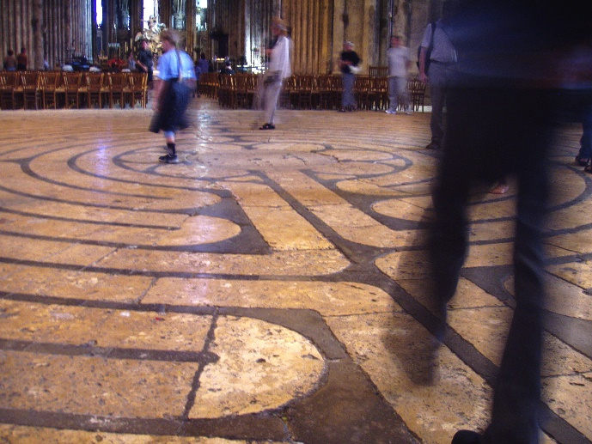
During the 12th century the actions of the Crusades made travel to Jerusalem difficult and dangerous, so seven cathedrals throughout Europe were designated as alternative sites where pilgrims could journey. One of these was Chartres with perhaps the best known labyrinth embedded in its floor. The walk into the labyrinth marked the end of the physical journey across the countryside and served as a symbolic entry into Jerusalem.
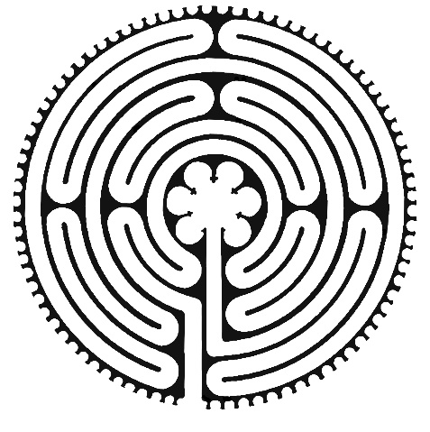
The Rectory Labyrinth is modelled on the Chartres labyrinth with seven circles, on a single path from the outside to the middle where the bird bath stands as a symbol of the water of life.

Walking the Labyrinth
Labyrinths are not mazes; there are no dead ends, so you cannot get lost. If you follow the path, it leads you inexorably to the centre, and retracing your steps brings you safely to where you began, but as T.S. Eliot says in the Four Quartets:
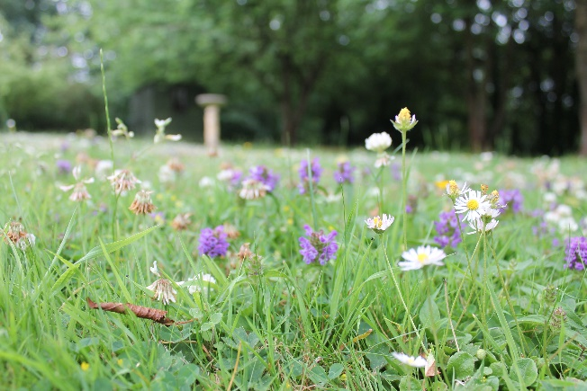
And the end of all our exploring
Will be to arrive where we started
And know the place for the first time.

To walk a labyrinth is always to go on a journey. It offers a body of mediation that parallels the inner journey of prayer and reflection, and is like making a mini pilgrimage. The path is not straightforward, there are many twists and turns, and you meet others coming and going, as you do in everyday life; people who are your companions on the road.
The way in is frequently spoken of as a time of releasing, the centre a place of receiving, and the way out a place of returning, as we assume our daily tasks in the world, often with new hope, fresh insights and perspectives. Travelling expectantly and attentively with an open heart and mind can lead to a greater understanding of who we are and to encounter with the God who, as the 13th century mystic Meister Eckhart says, yearns a thousand times more strongly for you than you do for Him.
Labyrinth Etiquette
Consideration of self and others is the cornerstone of labyrinth etiquette.
Choose the pace of your walk, and pause whenever you wish. If other people are also walking, it is acceptable to overtake them if they have chosen to travel more slowly. If you meet someone coming in the opposite direction on the path, then step aside to let them pass. You may choose to make eye contact, not to them, or not acknowledge them at all.
You may walk off the labyrinth at any time, walk around the perimeter, stay at the centre as long as you wish, sit on the path or at the centre, or even experience the labyrinth by watching others walk it.
Some people prefer to remove their shoes when walking, but this is entirely a matter of personal choice.
Aids to Reflection
You may begin your journey with questions, concerns, or worries that you want to explore with God. You might come in a spirit of praise and thanksgiving. You may want to reflect on a word you have been given, or an image that has caught your attention.
If you are not sure how to begin, you might find it helpful to take and activity card from the labyrinth box. These suggestions are drawn from a variety of sources and provide ideas of what to think about on the way in, when you reach the centre, and finally as you retrace your steps out towards the edge once more.
When you have finished your walk, ponder on the experience. You may find it helpful to note down your thoughts for further reflection at a later date.
Crossing the threshold of the labyrinth is a way of saying to God: I want to walk with you, and I invite you to walk with me.

The dates and times are:
28th June from 10 am to 4 pm which begins with a talk in the morning about how to use the labyrinth for those who are unsure,
30th July 2-5pm, 23rd August 2-5 pm and 24th September 2-5 pm.
Please drop in at any time. For more information please speak to Emma or pick up a leaflet.

